Professional development resource
Unit 2 Understanding and identifying proportional contexts
Lesson 2A(ii) : Percentages on the bar model

Lesson summary
- In this lesson students continue to work with the bar model, as a follow on from the work begun in lesson 2a.
- The context of a computer download bar is used to introduce the percentage bar. Students experience a range of other contexts, but unlike the contexts chosen for lesson 2a here, the contexts do not immediately conjure up a rectangular image if you were to represent them pictorially.
- Students are encouraged to develop their use of the percentage bar to answer a wide range of percentage questions including finding a percentage of, percentage reduction, reverse percentage problems and expressing one amount as a percentage of another.

Focus of students’ learning
- To develop strategies for accurately portioning up a percentage bar, using landmark percentages such as 50%, 25%, 75%, 10%, 20%, 15%
- To be able to draw a percentage bar to represent a particular context
- To be able to accurately place other information that they know to be true on their percentage bar
- To be able to use the bar to solve a range of percentage problems
Lesson preparation
- This lesson is designed as a follow on from lesson 2a, but could be accessed without knowledge of lesson 2a.
- Mini whiteboards can help students to readily draw their own percentage bars without feeling constrained by having to use a ruler, and having to be neat.
- Powerpoint slides are available

The Lesson
Stage 1: Downloading software – Q1 & 2.
Students consider whether the computer download bar in the picture is to scale or not. They portion out the bars to help them work out how long the packages will take to download. Students can be encouraged to come to the board to demonstrate their thinking on the percentage bar.
Supermarket fundraising – Q3 & 4 (on worksheet 1)
Students consider whereabouts the amount of money would sit on the percentage bar. This could involve rounding the money, placing landmark percentages such as 50%, 25%, 75% on the bar and placing the money in relation to these. Strategies will vary and it is worth seeing these as a class or in pairs.
£0
£2500
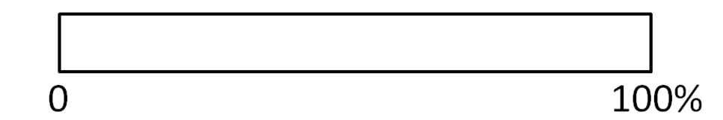
.Community Centre
Aim: to update the security lighting
Money raised so far | £1494
Target amount | £2500
Stage 2: What’s a fair amount to tip? – Q5 - 7
The context of tipping in restaurants is used to steer the students towards the landmark percentages of 10%, 20% and 15%. Students are required to develop strategies for accurately placing these on a bar.(Q5c) It can be interesting to hear the variety of strategies used by students to place 10% i.e how they partition a bar into 10 equal pieces.
In Q6 (worksheet 2) they use percentage bars to help them identify whether the tip given for a particular meal is closest to 10%, 20% or 15%.
Waiter / Waitress | Total bill | Amount of tip
Jo | £ 96.30 | £12
Stage 3: Sale prices – Q7 - 9
Students develop their use of the bar to include finding other percentage amounts, by combining the landmark percentages where appropriate. They are required to reduce prices by a certain percentage, on the bar; this involves working backwards from 100% once they have found the value of the reduction. Again, strategies will vary and one of the teacher’s roles is to select solutions for the students to demonstrate, which showcase the different levels of sophistication of the various solutions.
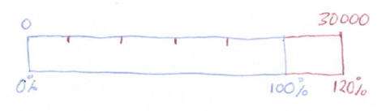
Stage 4: Price rises – Q10 – 12
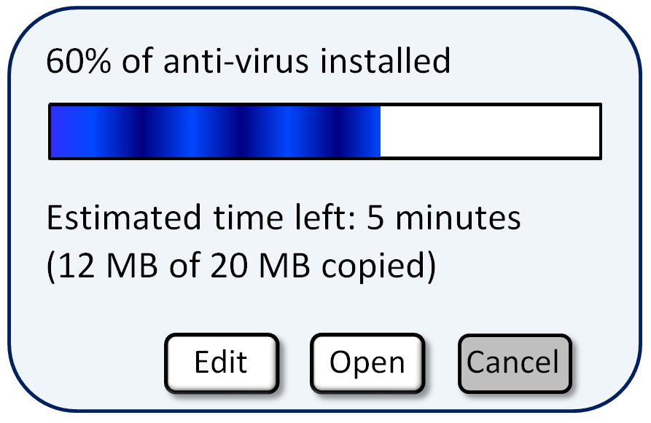
The percentage bar has great potential as a means of enabling students to make sense of problems where the original amount is unknown. Here, students consider how to represent problem of this nature on a percentage bar. Many are then able to use the bar to deduce other percentage amounts and can usually find a pathway to the original amount (100%). In this section, we only look at problems where the price after an increase is what is given, although there is obviously the potential to use a percentage bar to find the original amount given the decreased amount.
Test results
The percentage bar also provides a means of making sense of questions where you need to express one amount as a percentage of another. Students are directed towards using a percentage bar to do this. However, where students are familiar with an alternative method such as convert to a decimal and multiply, they can be challenged to try to see their method in terms of the bar. Forcing students to work across representations / strategies in this way can help them to develop a rationale for why the procedure works.
Lesson commentary

Stage 1: Downloading software – Q1 & 2
- Q1a – students will be aware that the download bar on a computer does not always behave consistently in that it can take a while to load in the early stages, but then appears to speed up near the end, this is worth discussing. However in the case of the download bar shown here, students will be able to offer several suggestions as to why the shading does appear consistent with a 60% download. It can be helpful to bring students to the board to demonstrate their thinking by marking up the bar.
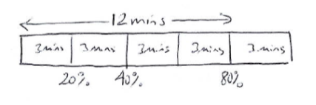
- Q1b – It is helpful to identify where to place 5 minutes on the bar, this might be marked by writing 5 mins inside the white block, or over the top of the bar using arrows. A useful prompt can then be to ask the students to look at the picture and say what else they know. Some may be able to identify that half this white block represents 20% which corresponds to 2 ½ mins. Therefore the total time to download would be 12 ½ mins.
- Q2 – a likely strategy is to halve the 80% block and halve it again. Students will vary in the way they draw and label up their bar. Here is one possibility:
Supermarket fundraising – Q3 & 4
- Q3 - Some students may have experience of this fundraising scheme, the store is ASDA. Often it will be the children rather than the parents who decide in which container to put the tokens. Q3a - The organisation that appears to have the most tokens is the Heaton Norris Community Centre. Q3b - Suggestions will vary: It is possible that shoppers are choosing this more than the other two organisations because the community centre is likely to be used by a broader group of local people, than the Primary school, or the House for the Blind.
- Q4 – It is important that the students are encouraged to estimate here, rather than becoming bogged down in the specific numbers. Mini-whiteboards can help with this. Students are likely to use strategies such as halving and halving again to see how close they get to the given totals. Here are some possible approaches:
According to these figures, the primary school is closest to meeting its target.
Stage 2: What’s a fair amount to tip? – Q5 - 7
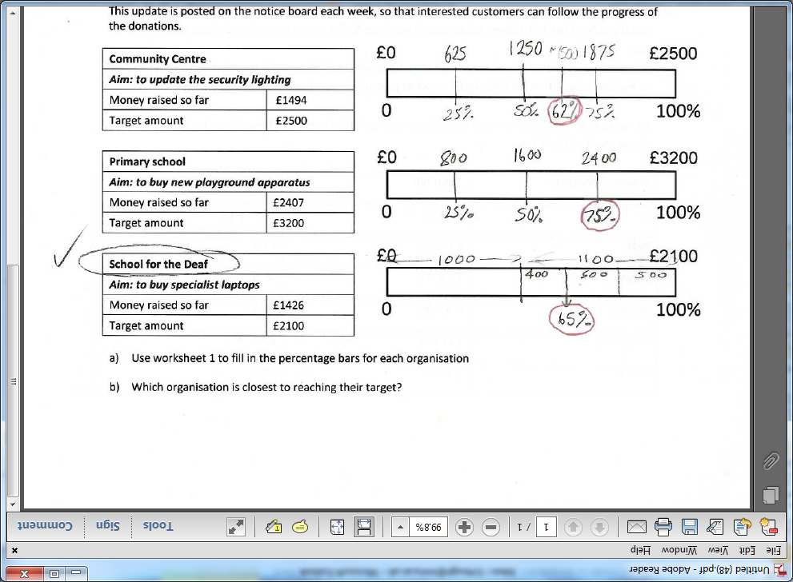
- Q5a - It is worth discussing this context; the students should have lots of stories about when their family leave a tip, such as in restaurants, at the bar, for workmen, window cleaners etc. For Q5b suggestions will vary: ‘round it up to £40’, ‘give 10%’, ‘put a £1 in each’ … and so on. If the service is poor, they may decide not to leave any tip.
- Q5c – Students will need to section the bar into 10 equal parts and may find whiteboards helpful to practice. Some students may just guess the position of 10%, others may be more strategic: ‘I put in half way, then imagined halving the first half again and put a line either side of this to make one block, and then filled in all 10 blocks’. By eye, methods are to be encouraged, although some students may wish to use a ruler as a means of figuring out where to put the 10 blocks. Answers will vary for Q5d depending on what size of tips they have suggested.
- Q6a – In question 5 students will predominantly have been working with 50%, 25% and 75%. Now they are pushed to consider 10%, 20% and 15%. Again, the realism of the amounts of money can be dealt with by using approximations; this is what you would do in a restaurant. When considering the total of say £96.30, students may wish to think of this as £96, or even £100 pounds. Some of the students will not be secure about what 10% of £96 is worth, and it depends how much you want to strip back in terms of how you deal with this.
Some students may want to find 10%, 15% and 20% in sequence for each part. Others will keep an eye on the size of the tip and where this could be placed on the bar to help them decide whether the tip is closest to 10%, 15% or 20%
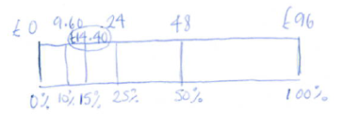
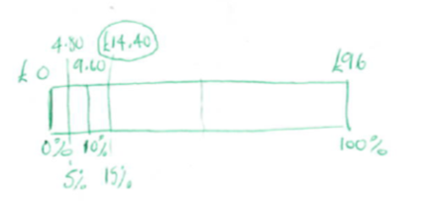
Students may adopt a variety of strategies for finding 15% E.g.

Jo’s tip closest to 10% (just), Pete’s tip closest to 15%, Steve’s tip closest to 5% (not even 10%), Naveed’s tip closest to 10%, Rhiannon’s tip closest to 20% , Nisha’s tip closest to 15% , but these may vary depending on how much estimating went on at the initial stage.
Q6b – Opinions will vary. He could work out how much he would have made if it had been a standard 10% charge and compare this with what he actually received.
Stage 3: Sale prices – Q7 – 9
- Q7a – there are various ways to complete the bar. It is worth encouraging students to demonstrate and explain their strategies to the rest of the class. Some students fill in 25%, then 12.5% then go back from 100% to 87.5%. Another strategy is to find 10%, then halve and halve again to find 2.5% and combine these to get 12.5% … and so on. Q8b - The reduced price at LAP gear is £455, which is cheaper.
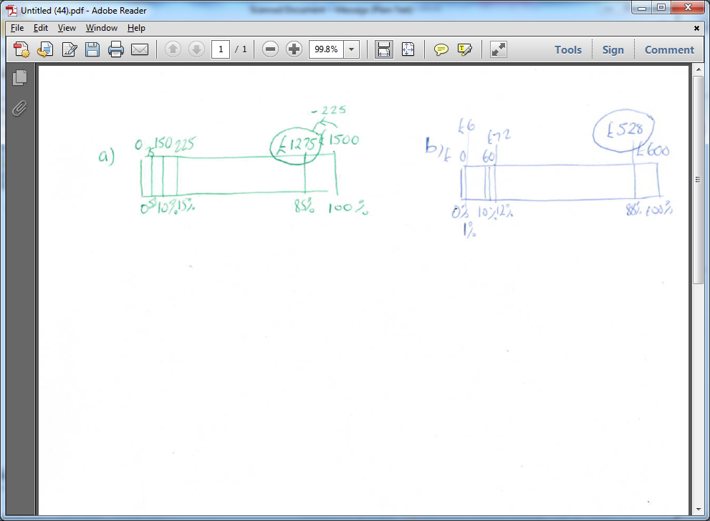
- Q8 - Students should be encouraged to draw their bars free hand, this is meant to be a free thinking tool where students fill in quantities according to what they see, rather than using a ‘standard procedure’ to fill in each bar. Some possible bars for parts a & b) are shown here:
Q8c – holiday price is now £1150, Q8d – Car price now £1975
- Q9 - Some students may opt to draw bars to answer this question. Others may return to methods they have previously used. When reviewing the solutions, it is helpful for the students to see more than one method. The teacher’s role can then be to ask questions like ‘Where can you see George’s method in the bar that Jemma has drawn?’ Forcing students to work across representations in this way can help to develop their insights.
In Scooter World the price is £114; In Scooters and Bikes the price is £112.50; In Scooter Zone the price is £110, so Scooter Zone is the cheapest.
Stage 4: Price rises - Q10 - 12
- Q10 is designed to help students consider the contexts of appreciation and depreciation. They may have several experiences to draw on, such as buying and selling items on ebay. They may be aware that football clubs for example, tend to increase the price of their season tickets over time. A new flat screen television is a lot cheaper to buy now than when they first came out. Yet if they were to buy a new flat screen television today, it would be worth a lot less if they tried to sell it on second hand the next day.
- Q11a- discussions could centre on the following sub-questions: In what order was the bar drawn? / Why is the 100% not at the end of the bar / How do you know where to place the 120% label in relation to the bar, etc. In part b, some students are able to fill in the middle of the ‘new’ bar as 15,000 and figure that this must match with 60%, therefore 20% is 5000. Other students find 20% by splitting the 30,000 into 6 parts. Q11c – 25,000 capacity before the increase.
- Q12 – students draw their own bars and use them to deduce the original amounts. a) original weight = 24g, b) original price = £75 c) original price = £240

Test results – Q13
- Q13a -Student approaches will vary. Some students fill in 25% and 75% and then recognise that a mark of 50 out of 80 falls right in the middle of 50% and 75% and therefore corresponds to 62.5%. Other students may see that to place 50 on the bar, the block between 40 marks and 80 marks needs to be split into 4 equal parts.
Q13b &c – Some students will draw bars, to find the corresponding percentages of b) 80% and c) 65%. Other students may opt to use an alternative method. I.e to convert 32 out of 40 do 32 ÷ 40 x 100. It is useful for the whole class to see both methods and to try to figure out where they can see one method within the other. For example, where can they see the method 32 ÷ 40 x 100 on the bar?

Adapting the lesson
- In previous trials most of the material in this lesson was accessible to all levels of students. The differentiation comes from the ways in which students tackle each problem.
- Lower attaining students are usually confident to fill in 50%, 25%, 75% and even 10% followed by 20%, 30% and so on. They may struggle to go straight from 100% to filling in say 20%. Partitioning quantities into say 5 or 3 parts can prove challenging and they may favour guess and check methods to do this, rather than division. Alternatively, they may develop the strategy of filling in 10% each time and deduce other percentage portions in relation to their 10%.
- Many students will have experience of answering percentage questions and may well have retained some methods for doing so. These students are still expected to work on a percentage bar. However, it is worth acknowledging their previous methods and asking them to describe where they can see their method on the bar.
Suggestions for lesson study focus
You might want to consider these aspects of student’s thinking:

- In what ways does the bar model enable students to make sense of the ideas connected with percentages?
- The bar model facilitates independent solution strategies. You could try to capture some examples of these for a particular question.
- What evidence can you gather to show that some students find it difficult to go beyond portioning into halves and quarters?

You might also want to consider pedagogic aspects such as these:

- In what ways can the teacher help students to share their strategies with each other and to listen to each other’s thinking. This could be in a paired, group or whole class setting
- In conjunction with this, how can the teacher help develop a student’s ability to interrogate each other’s thinking
- How does the use of mini-whiteboards influence the responses gained from individual students?

Research background to the lesson
- This lesson provides another opportunity for students to see and work with the bar model. In Realistic Maths Education (RME), the bar model is seen as a very helpful way of enabling students to structure their thinking in a number of topic areas. For a detailed exemplification of how the bar model is used and developed for the case of percentage, see Van Den Heuvel-Panhuizen (2003); ‘The didactical use of models in Realistic Mathematics Education’.
- When this approach was trialled in the UK, project teachers reported how helpful the bar model was as a way of enabling their students to make connections across many topic areas that students may previously have viewed as unrelated. (See ‘Using Realistic Mathematics Education in UK classrooms’, P. Dickinson & S.Hough at www.mei.org.uk/files/pdf/RME_Impact_booklet.pdf )‎

Downloading software

- John wants to download a new game on his computer. First, he has to install some anti virus software. After a few minutes the screen on his computer looks like this:

- John stares at the screen and wonders how accurately the blue bar represents the information. How can you tell how accurate it is?
- How could you work out the total time the anti-virus should take to install?

- Later John begins to download the new game. After 12 minutess the download bar looks like this:



John makes a sketch of the bar and wonders how to figure out how long is left to download.

Make a copy of the bar and show how you can use it to figure out how long is left.

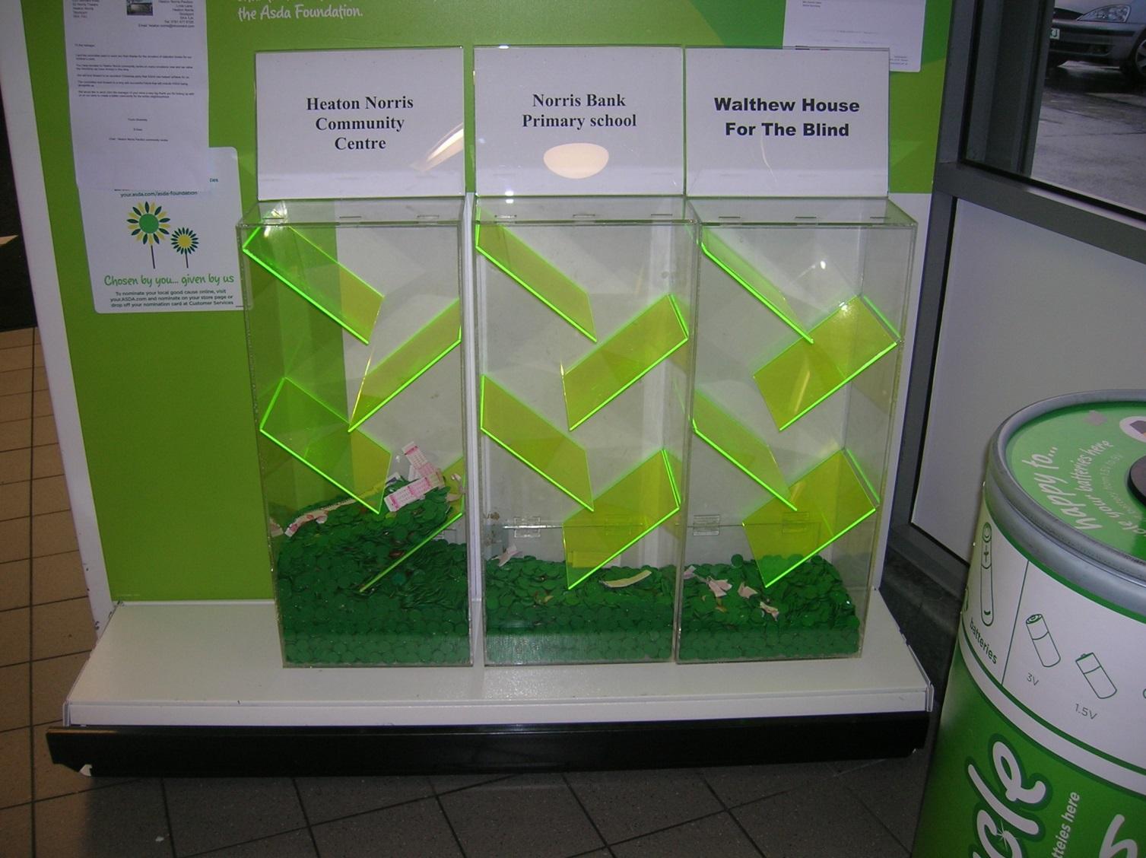
Supermarket Fundraising
- A major supermarket has a new fund raising scheme aimed at supporting local communities. Shoppers can earn tokens to give to a charity of their choice. The number of tokens gained depends upon how much the shopper spends.
The checkout worker issues the tokens to the shopper, who then chooses which of the three local organisations they would like the tokens to go. The supermarket converts the tokens into money and when the target amount is reached, they present the local organisation with a cheque.
- According to the picture, which organisation has the most tokens?
- Why do you think more shoppers are choosing to give their tokens to this organisation?
- Once a week, the manager empties the tokens and updates the record of the total amount of money raised for each organisation towards their target. He puts this information in a table and fills in a percentage bar. This update is posted on the notice board each week, so that interested customers can follow the progress of the donations.
£0
£2500
Community Centre
Aim: to update the security lighting
Money raised so far | £1494
Target amount | £2500  £0  £3200  £0  £2100
Primary school
Aim: to buy new playground apparatus
Money raised so far | £2407
Target amount | £3200
House for the Blind
Aim: to buy specialist laptops
Money raised so far | £1426
Target amount | £2100
- Use worksheet 1 to fill in the percentage bars for each organisation
- Which organisation is closest to reaching their target?
What is a fair amount to tip?

- a) Name some situations where you or your parents have left a tip

b) The price of a family meal in a restaurant comes to £36. 40. How much tip would you leave if the service had been excellent? How much would you leave if it had been poor?

- Make a copy of this percentage bar and mark on the positions of 10%, 15% and 20% as accurately as you can

- How close are the tips you suggested leaving in question 5b) to 10%, 15% or 20%

- Some restaurants and cafes in the UK include a tip (known as service or gratuity) in the bill. This is usually 10% of the bill. Other restaurants leave it up to the customer to decide how much to tip or not.
Giovanni owns an Italian restaurant where a tip is optional. Giovanni is wondering whether to start to include a tip within his bills, and if so what percentage to charge.

He looks at the record of takings from the previous Saturday night. These show the total bill and the amount left as a tip:
Waiter / Waitress | Total bill | Amount of tip
Jo | £ 96.30 | £12
Pete | £140.52 | £20
Steve | £ 76.14 | £ 5
Naveed | £ 45.95 | £ 5
Rhiannon | £125.72 | £25
Nisha | £ 60.02 | £10

Giovanni wonders what sort of tip customers are leaving as a percentage of the bill

- Look at the tips for each waiter/waitress and decide whether the size of tip is closest to 10%, or 15% or £20% of the bill. (Use the bars on worksheet 2 to help you.)
- Based on these tips would you recommend Giovanni to start putting a standard 10% tip on his bills or not?

Sale prices

- Deli wants to buy a laptop for his son for Christmas. He uses the internet to compare the price in various stores. In PC Express, the laptop is priced at £479, whereas LAP Gear are offering the same laptop for £520 with a 12.5% reduction.
Deli sketches a bar to help him work out the price in LAP Gear. He starts like this:
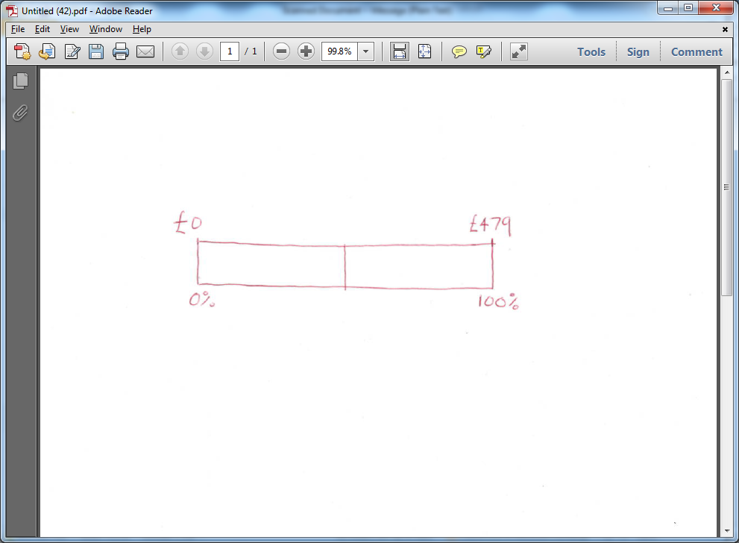

- Make a copy of the percentage bar and complete his calculations.

- Which online shop is selling the laptop for less?

- Draw bars to help you work out

- The price of a £1500 computer after a 15% reduction

- The price of a £600 washing machine after a 12% reduction

- The price of a £ 1250 holiday with 8% off

- The price of a £2500 car with 21% off

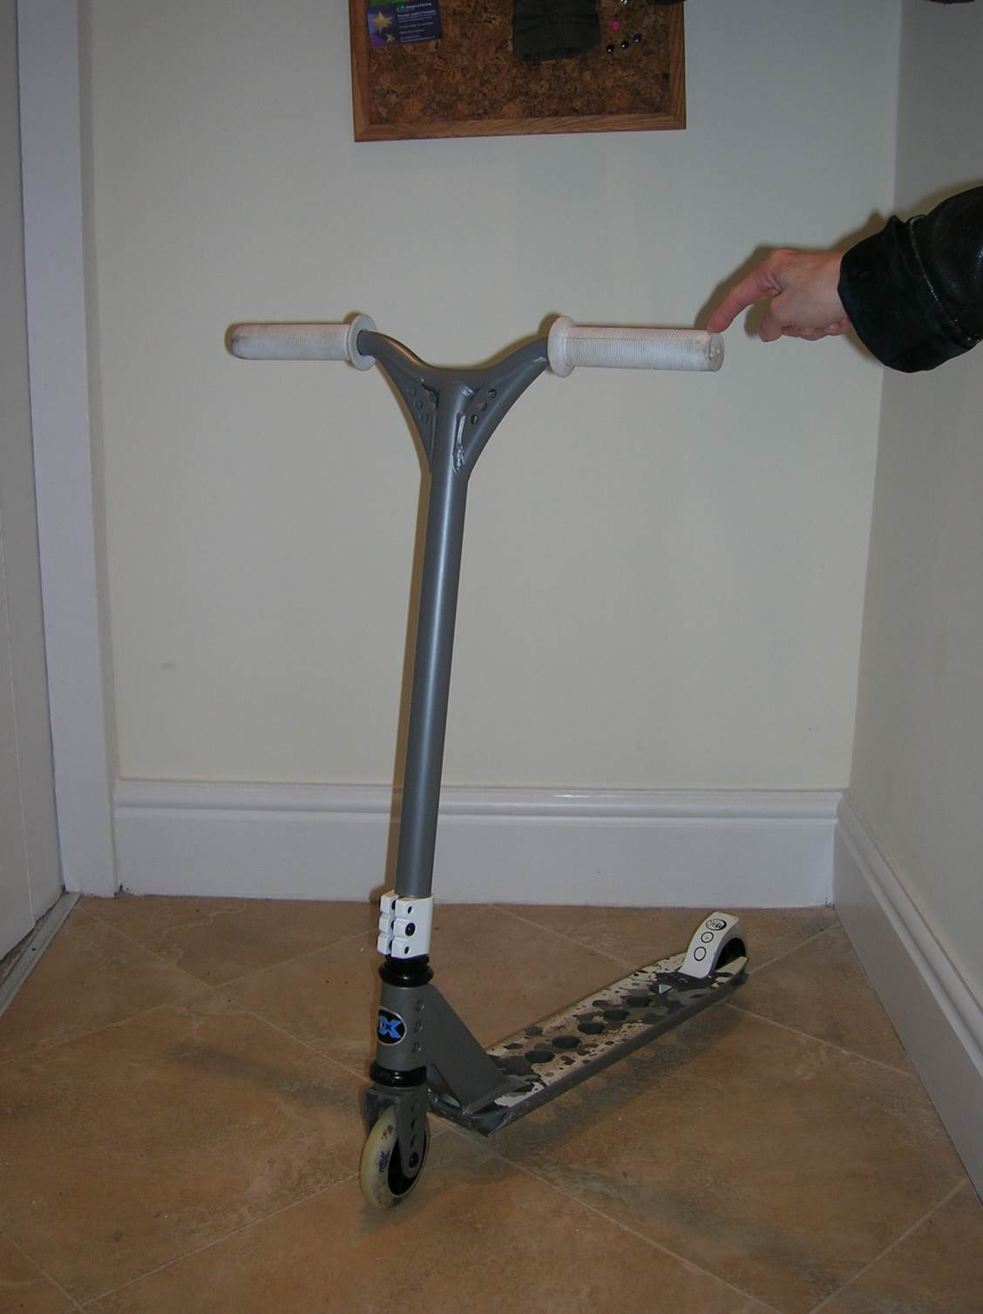
- Sue is looking to buy a scooter for her two children for Christmas. She finds the one she wants on offer in three different on line stores.

The offers are as follows:

Scooters and bikes
Mega scooter on special offer: Take 25% off the price
Normal retail price £150
Scooter world
Mega scooter reduced by 40% of the RRP
RRP £190

Scooter zone
Mega scooter on offer: knock 1/3 off the price
Normal retail price £165

Which store is the cheapest for this scooter?

Price rises

- a) Have you ever bought or sold anything on EBay? Did you make a profit or a loss?

- How does the price of the following items change with time
- A car ii) A season ticket
- A new flat screen television iv) A mobile phone

- Name some other things which might increase or decrease in price over time

- a) A football stadium has increased its seating by 20%. The stadium can now hold up to 30 000 supporters. Describe how the bar drawn below represents this information

b) Copy the bar and fill in any more information that you know

- How many supporters could the stadium hold before the increase?

- Draw percentage bars to help you answer the following questions:

- A brand of crisps increases the weight of crisps in a bag by 25%. The new bags now holds 30 grams of crisps. What weight of crisps used to be in a bag?

- The price of a coat is increased by 20% to £ 90. What was the price originally?

- The price of a flight from Manchester to Paris is increased by 30%. It now costs £312. What was the price before the increase?

Test results

- Eli wonders if he can use a percentage bar to convert his test results into percentages. He recently scored 50 out of 80 in a maths test. He starts by drawing his bar like this:
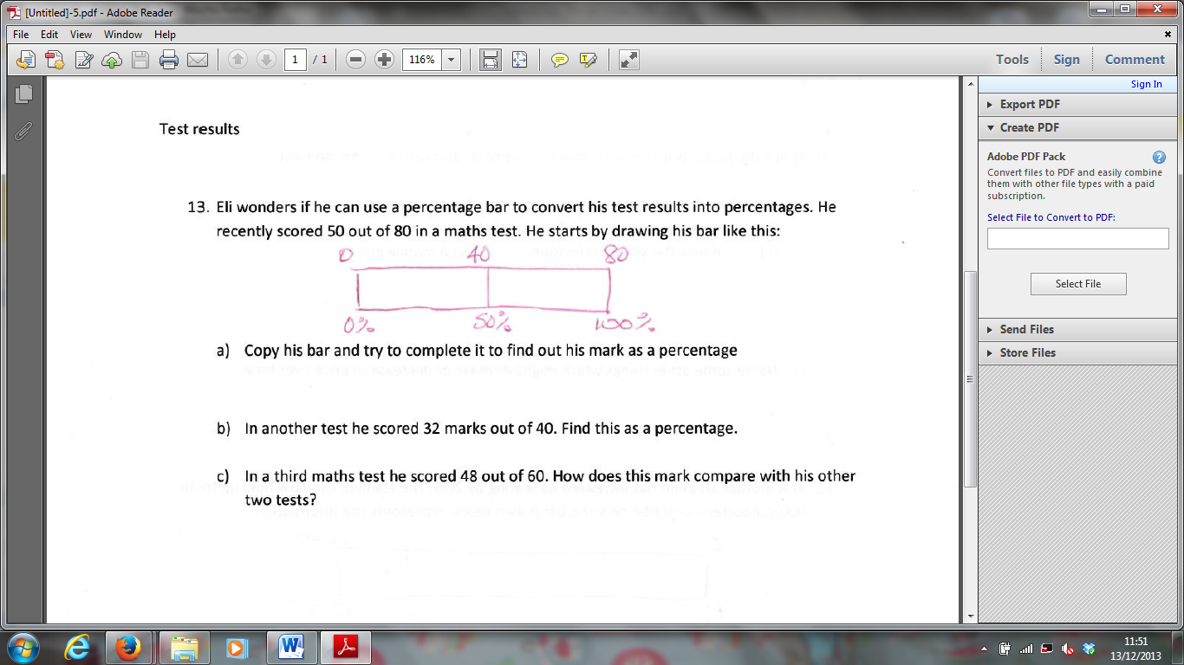

- Copy his bar and complete it to find out his mark as a percentage

- In another test Eli scored 32 marks out of 40. Find this as a percentage.

- In a third maths test Eli scored 39 out of 60. How does this mark compare with his other two tests?

Lesson 2b
Worksheet 1

Question 4
Once a week, the manager of the supermarket empties the tokens and updates the record of the total amount of money raised for each organisation towards their target. He puts this information in a table and fills in a percentage bar. This update is posted on the notice board each week, so that interested customers can follow the progress of the donations.
£0
£2500
Community Centre
Aim: to update the security lighting
Money raised so far | £1494
Target amount | £2500  £0  £3200  £0  £2100
Primary school
Aim: to buy new playground apparatus
Money raised so far | £2407
Target amount | £3200
House for the Blind
Aim: to buy specialist laptops
Money raised so far | £1426
Target amount | £2100

- Fill in the percentage bars shown above, for each organisation.

- Which organisation is closest to reaching their target?

Lesson 2b
Worksheet 2

Question 6
The table below shows a record of some of the takings in Giovanni’s restaurant on a Saturday night. These show the total bill and the amount left as a tip at some of the tables.

Waiter / Waitress | Total bill | Amount of tip
Jo | £ 96.30 | £12
Pete | £140.52 | £20
Steve | £ 76.14 | £ 5
Naveed | £ 45.95 | £ 5
Rhiannon | £125.72 | £25
Nisha | £ 60.02 | £10

Giovanni wonders what sort of tip customers are leaving as a percentage of the bill

- Look at the tips for each waiter / waitress and decide whether the size of tip is closest to 10%, or 15% or to £20% of the bill. Use the bars drawn here to help you.

Jo

Pete

Steve

Naveed

Rhiannon

Nisha

- Based on these tips would you recommend Giovanni to start putting a standard 10% tip on his bills or not?

