Lesson practice sheet
Complete the 6 × table. Draw an arrow to show the jumps. Then write the correct multiplication sentence.

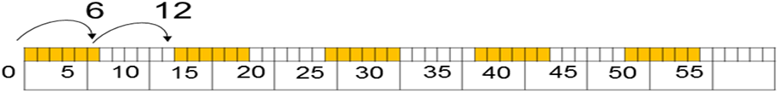
What is the multiplication sentence?
How long is the red line?

___ X ___= or ___ X ___ = ___ X_ __ = ___ X_ __ =

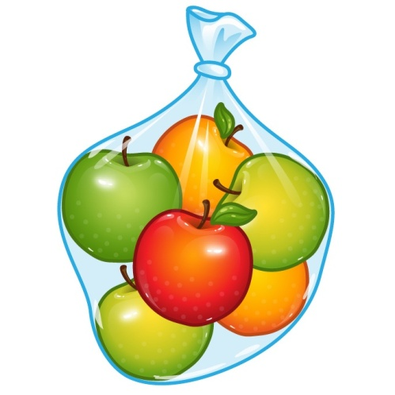
One bag of fruit contains 6 apples. How many apples are in 9 bags?
___ × ___ = ___ × ___ =
Complete the following:
1 × 6 + 3 = 6 × 4 – 3 = 4 × 6 + 5 = 3 × 6 – 2 =
4 × 3 + 3= 8 × 3 – 4 = 6 × 6 + 6 = 5 × 6 – 6 =
Write the correct symbol < = >
6 × 4 ( __) 8 x 3 2 × 3 + 4 ( __) 6 × 2 – 1 8 × 6 – 5 ( __) 7 × 6 + 4
___ ___
Fill in the blanks.
There may be more than one answer.
6 × __ < 47
33< 6 × __
Create your own < = > questions using the 3 × and 6 × table. Challenge yourself by using + and -.

